1. **How to change user password in Linux ?**

* You can new password to user using passwd command

Syn- Passwd u1

1. **How to add and delete user in Linux ?**

* Using useradd , userdel command

Syn- useradd u1 ( user name)

userdel username

1. **How to switch user from 1 id to another id ?**

* Using su command
* Syn- su username

1. **Shutdown / Reboot / Exit command**

* Init 6 - Reboot
* Init 0 – Shutdown
* Logout – Exit

1. **How to insert , delete , copy and save in a file with VI editor ?**

* i – insert
* yy – copy
* dd – delete
* p – paste
* :wq - save and quit

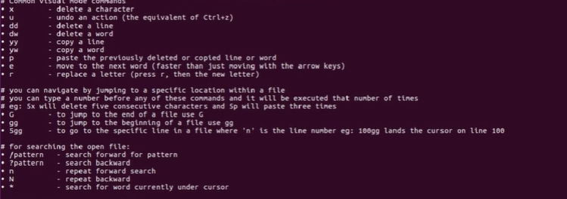

1. **Use of scp command**?

* SCP (secure copy) is a command-line utility that allows you to securely copy files and directories between two locations.
* With scp, you can copy a file or directory:
* From your local system to a remote system.
* From a remote system to your local system.
* Between two remote systems from your local system.

@Refer this - <https://linuxize.com/post/how-to-use-scp-command-to-securely-transfer-files>

1. **How to change ownership of the file Directory?**

Using chown command

1. **How do I find out owner / group name for a file?**

* Using ls -l command
* Ls -l filename

1. **Chmod command ?**

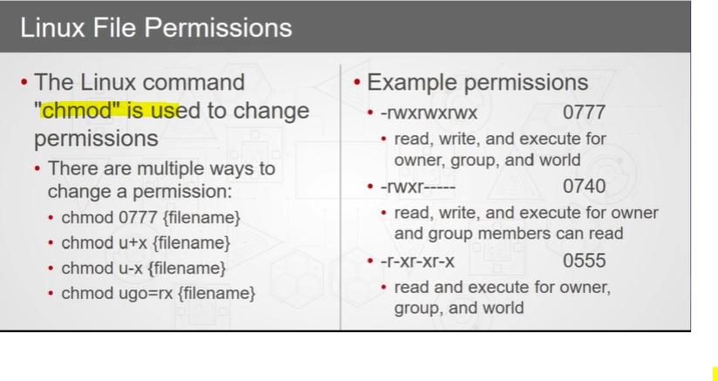

1. **Basic Linux Commands ?**

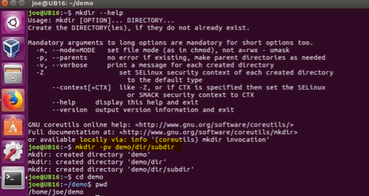

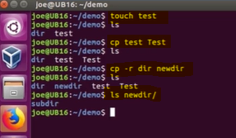

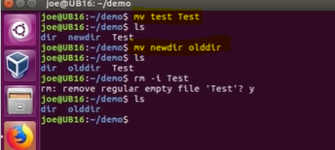

@ Refer following link for more details-

<https://atos.percipio.com/courses/f95b8a80-7b7b-11e8-b52b-2d384025e4de/videos/25414390-7b7e-11e8-b52b-2d384025e4de>

1. **DF Command.**

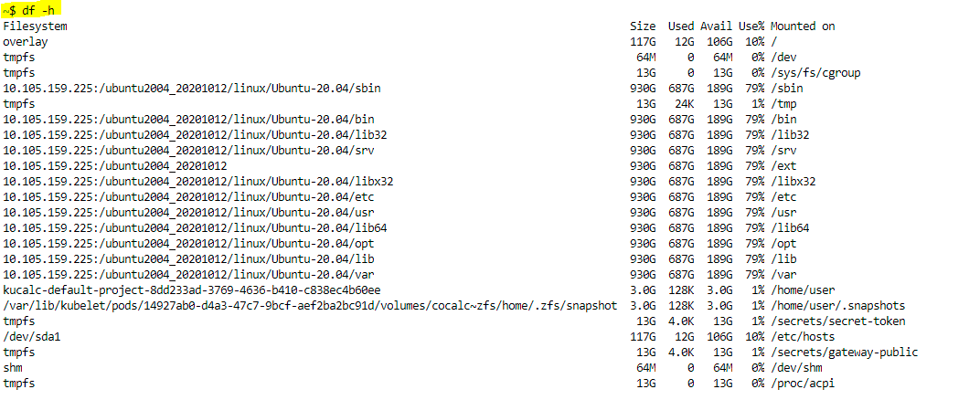

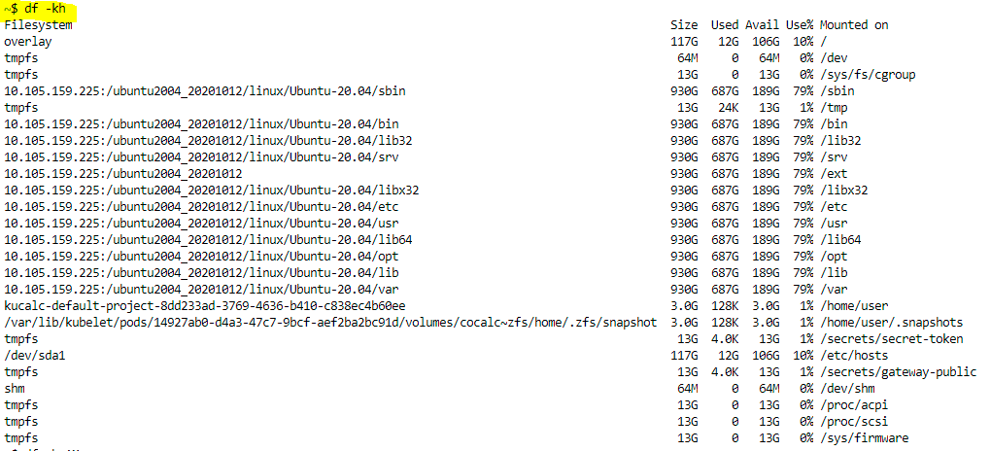

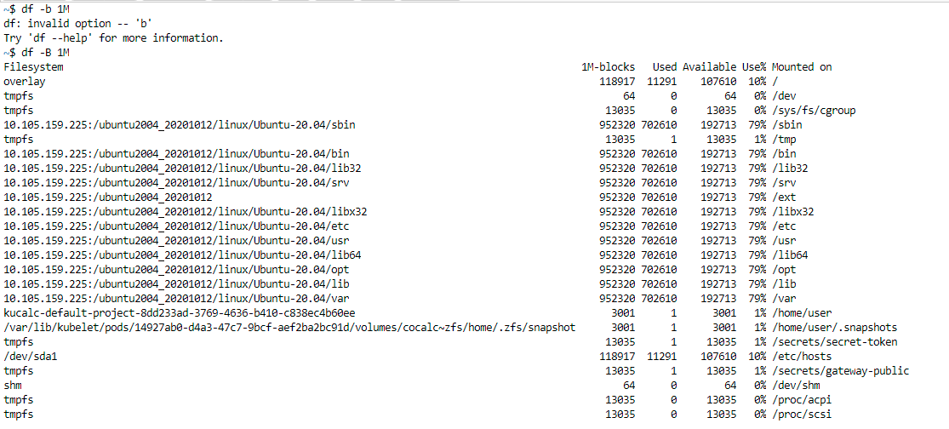

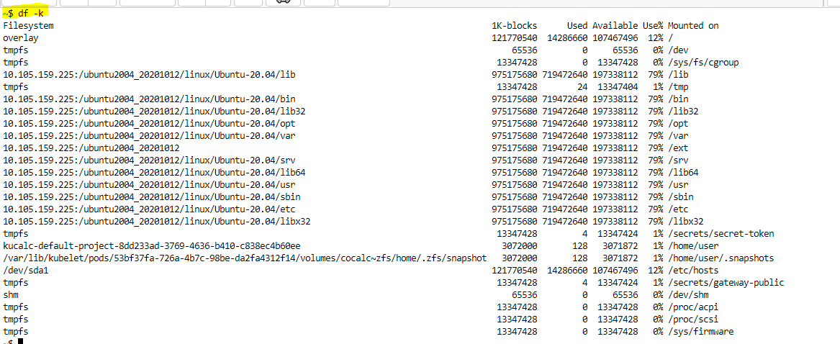

# HOW TO FIND PID OF THE PROCESS?

 The PID of the process can be found using “ps-ef” command.

# PS -EF COMMAND IN UNIX:

This command is used to find the PID (Process ID, Unique number of the process) of the process. Each process will have the unique number which is called as PID of the process.

**Ex:**



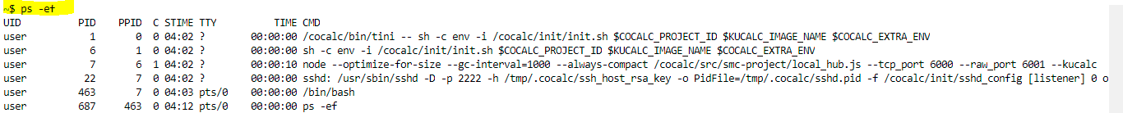

@ https://fresh2refresh.com/unix-tutorial/advanced-unix-commands/ps-ef-command-unix/